The following RACE COMPETION RULES will apply for the Jackie Fairweather Memorial Triathlon SPRINT DISTANCE – Age Group Draft Legal event to be held on 30th October 2022.

From the TA Race Competition Rules (July 2022) – the following Rule advises:
3.15 Draft legal events for Age Group competitors
a. The WT Competition Rules apply including, but not limited to:
- Wheels having at least 12 spokes
- Disc wheels not being permitted in draft legal events
- Only traditional drop handlebars are permitted
- The handlebars being plugged
- Clip-on bars are not permitted
b. A competitor passing on the inside (left hand side) of another competitor will receive a Blue Card Time penalty for an illegal pass.
The competitor must present to the Bike Penalty Box for a 3-minute Time Penalty.

World Triathlon (WT) Competition Rules can be downloaded from (https://triathlon.org/development/technical_officials_docs/category/competition_rules )

UCI Approved equipment can be downloaded from
(https://www.uci.org/equipment/bh2JJzw1eB0n876rX2iB1 )

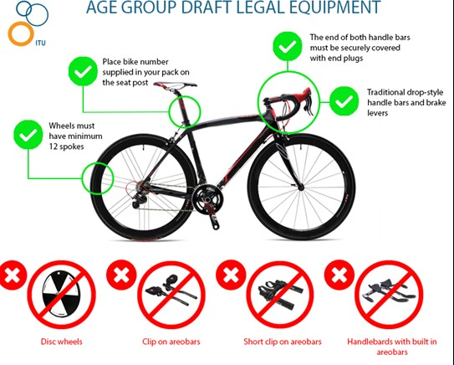

World Triathlon Competition Rules (28 January 2022)
Rule 5.2 Equipment
d.) For draft-illegal events, and Age-Group draft-legal events:
(i) Frames:
- The bike will be no more than 185 cm long, and 50 cm wide;
- The bike will measure between 24 cm and 30 cm from the ground to the centre of the chain wheel axle;
- There will be no less than 54 cm and no more than 65 cm between a vertical line passing through the centre of the chain wheel axle and a vertical line through the centre of the front wheel axle;
- The frame of the bike shall be of a traditional pattern, i.e., built around a closed frame of straight or tapered tubular elements (which may be round, oval, flattened, teardrop shaped or otherwise in cross-section). Bikes built around a diamond shape (no saddle down tube) or with a rear triangle which does not connect at the top of the down tube/top tube section are considered acceptable.
- Bikes provided with the UCI Time Trial homologation label (Code TT) are always allowed in World Triathlon draft-illegal events, even if they contravene any of the previous bullets in this 5.2 d.) (i) insert.

(ii) Saddle-position:
- There will be a vertical line touching the front-most point of the saddle which will be no more than 5 cm in front of, and no more than 15 cm behind, a vertical line passing through the centre of the chain wheel axle, and an athlete must not have the capability of adjusting the saddle beyond these lines during competition;

e.) Wheels:
(vii) For Age-Group draft-legal competitions, wheels must have the following characteristics:
- Wheels shall have at least 12 spokes;
- Disc wheels are not allowed.

f.) Handlebars:
(ii) For Age-Group draft-legal competitions, the following handlebar rules will apply:
- Only traditional drop handlebars are permitted. The handlebars must be plugged;
- Clip-ons are not allowed.

For your information and as per the World Triathlon (WT) Draft Legal rules, the following penalties will apply and be served at the Listed Penalty Box

5.5 Drafting:
b.) Draft legal events:
- It is forbidden to draft off a different gender athlete;
- It is forbidden to draft off an athlete being in a different lap;
- It is forbidden to draft off a motorbike or vehicle.

General Infringement
RULES | PENALTIES | WT RULE
Discard equipment or littering | - Warning and amend  - Time penalty – 10 seconds  In Bike Penalty Box | 2.1 a.) (xi)

Bike Course Infringement
RULES | PENALTIES | WT RULE
Drafting off a different gender athlete in draft legal events | - Warning and amend  - If not corrected: DSQ | 5.5 b.)
Drafting off a vehicle or motorbike in a draft-legal competition | - Warning and amend  - If not corrected: DSQ | 5.5 b.)
Blocking in a draft-legal Age Group competition | - Warning and amend  - Time penalty – 10 seconds  In Bike Penalty Box | 5.5 b.)

Transition Infringements
RULES | PENALTIES | WT RULE
Rack the bike improperly, unfastened helmet, or mount/dismount line | - Warning and amend  - Time penalty – 10 seconds  In Run Penalty Box | 7.1

Gai Webster
Technical Delegate
Jacqui Fairweather Memorial Triathlon

